***PCSchool Install***

# *Part 1 - Client Install:*

* Copy Backoffice install from S:/IT/Installers to c:\ - the desktop is fine for now as the files will be deleted after installing PCSchool

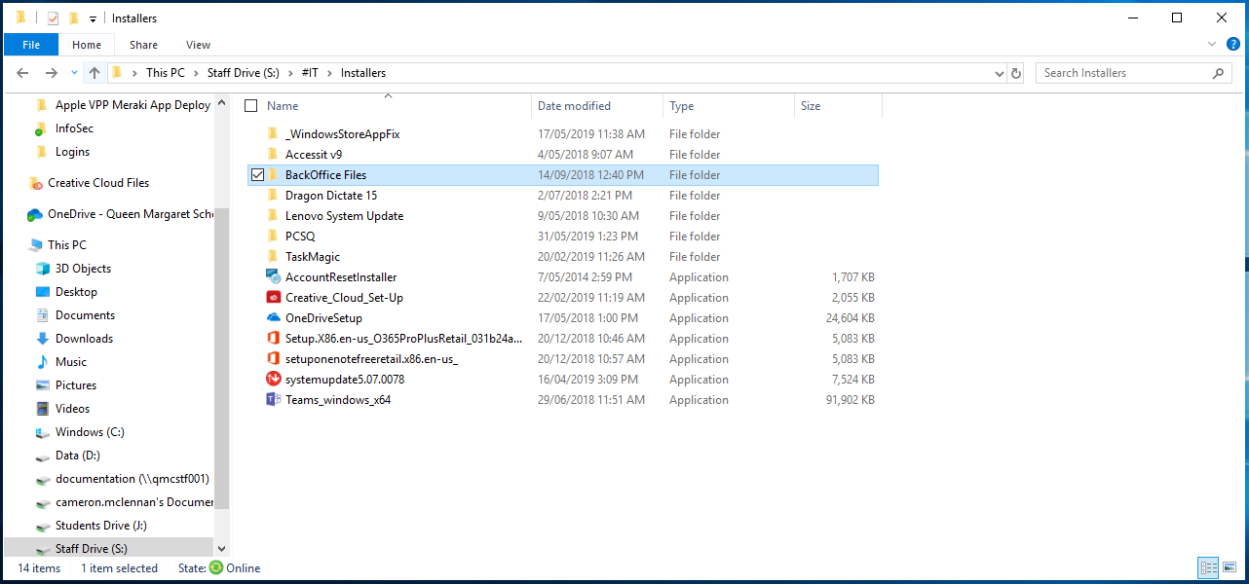

* Once the files are on the desktop, run sqlncli_x64

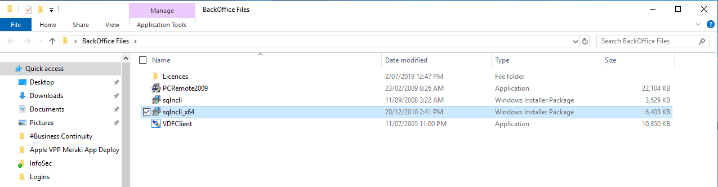

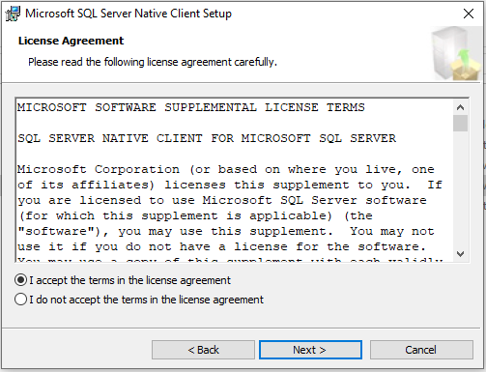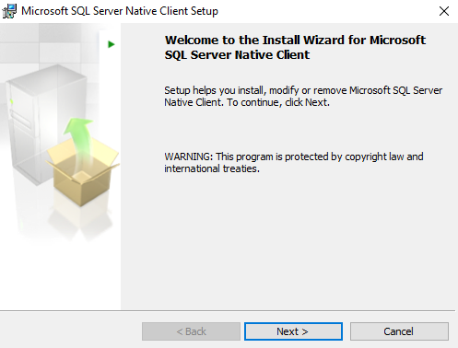

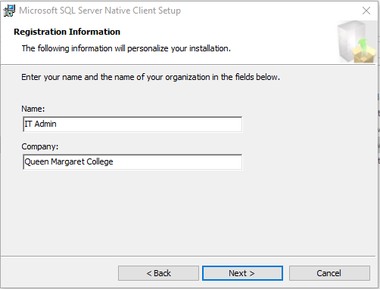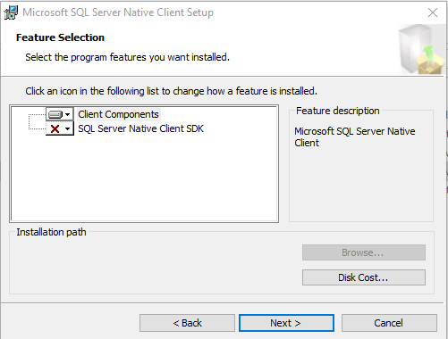

* + Fill in appropriate details for the person who will be getting the install ( top left image)

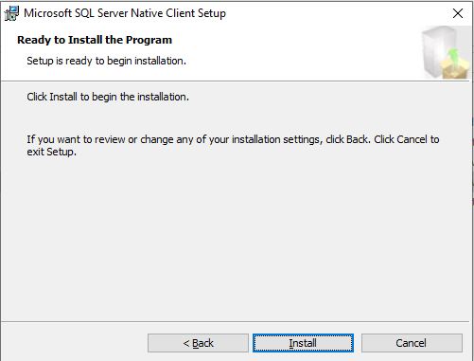

* Run PCRemote2009 as Administrator

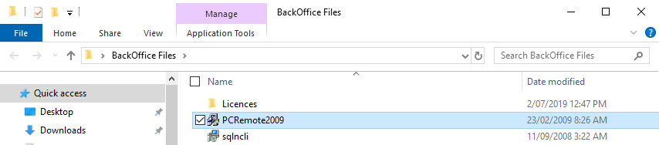

* Install client then press install client
* Accept default settings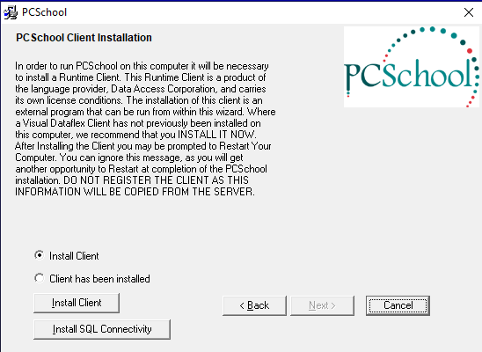

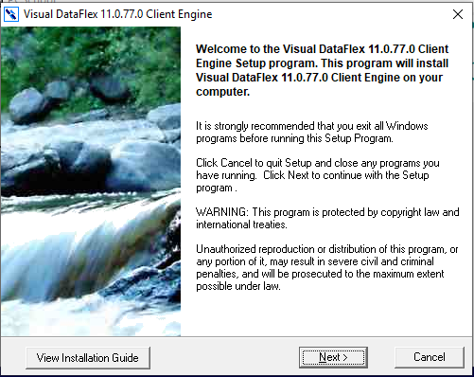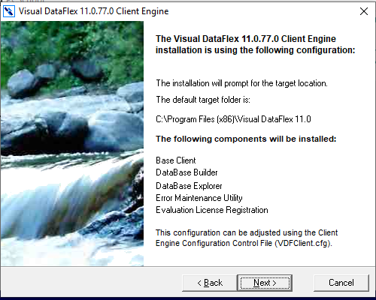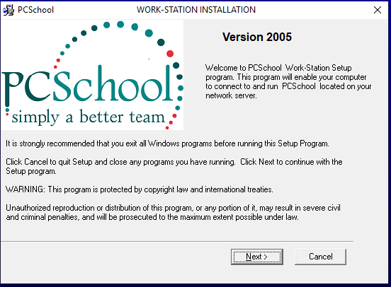

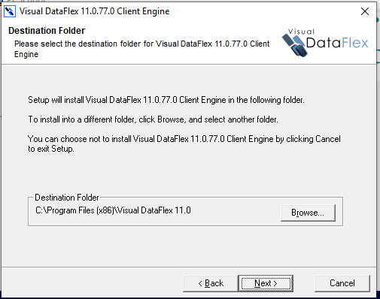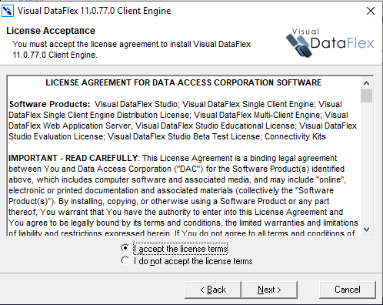

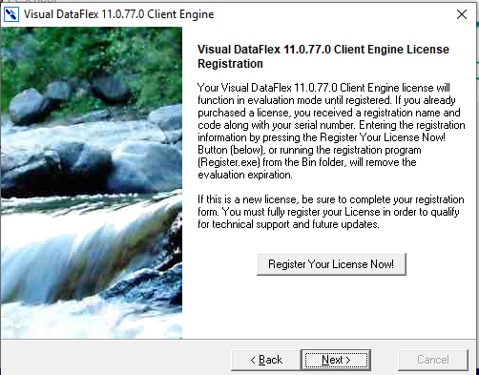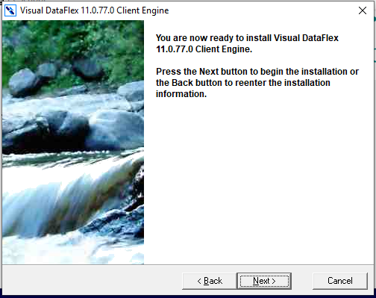

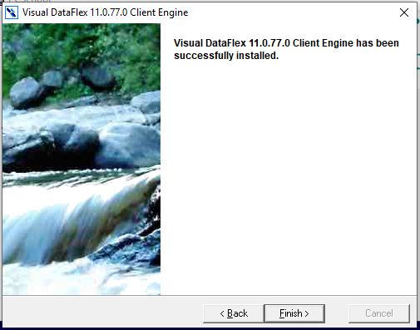

# *Part 2 – Visual DataFlex 11.0 Install:*

* *The client has now been installed. Change the radio button to “Client has been installed” and then click next*

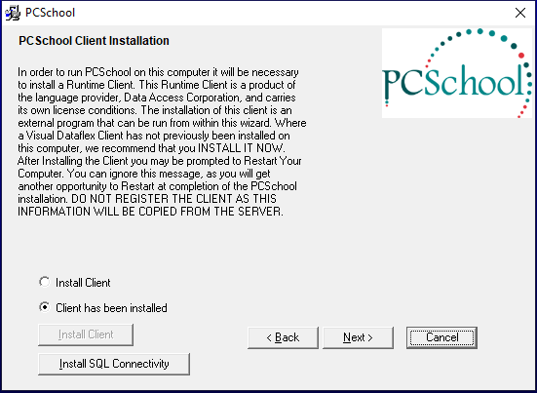

* Click “Browse” on the File Server Folder

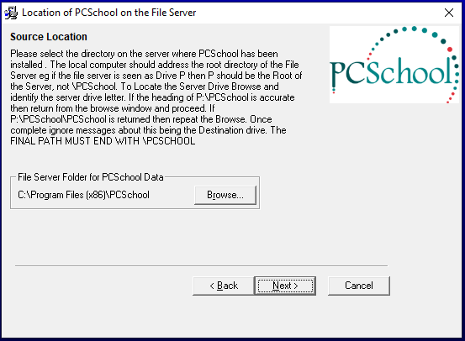

* Change path at top to \\qmcpcs002\pcssql\pcschool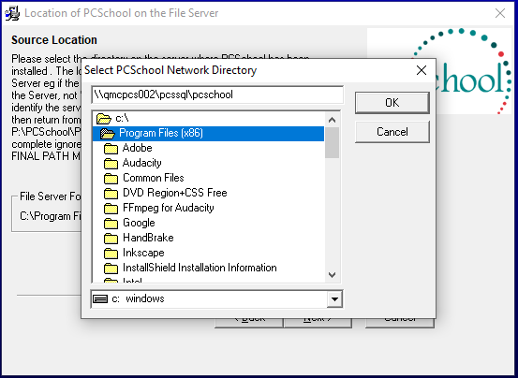 and then click “OK”
* Click next twice

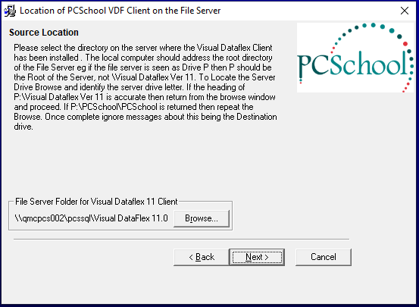

* Change destination folder to “c:/PcsLaunch”, click okay, then next

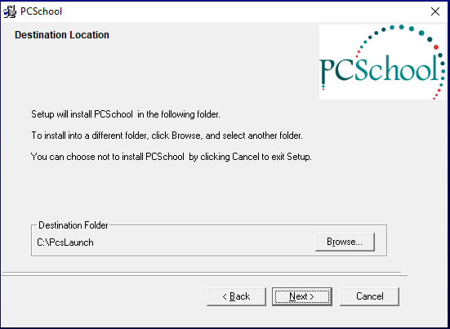

* When prompted for settings, change them to those as follows:
* 192.168.1.8
* *New users’ email address – I am using mine as the example*
* SMTP

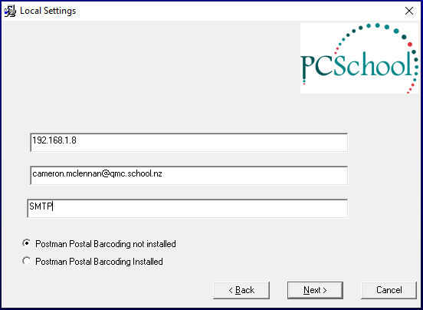

* Click Next, and then Next again to install

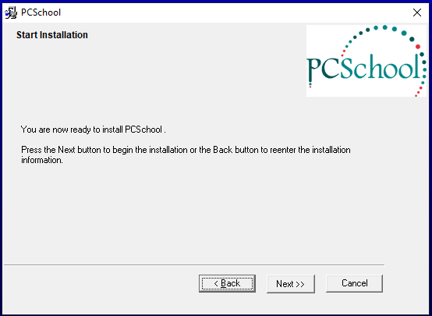

* Click okay to 4 succeeded messages, and then finish.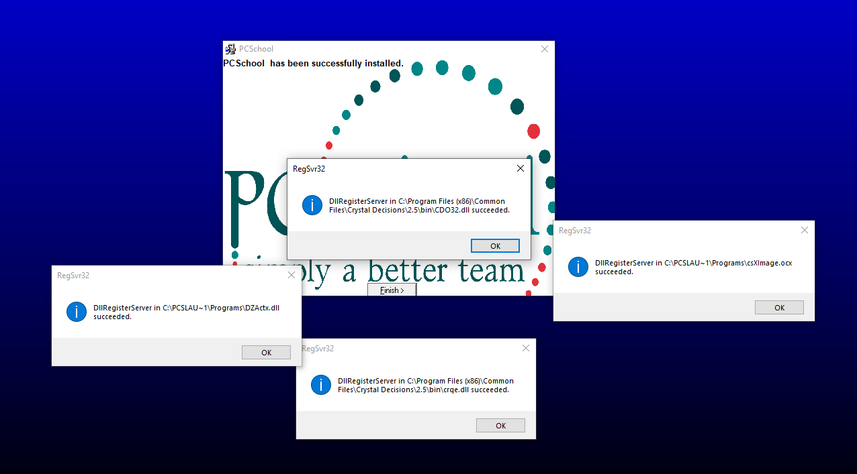
* Copy 4 license files from the backoffice file on the desktop (that you copied over before) to the visual data hex bin file, and replace the conflicts with the new files.
* The visual data hex bin file is in the default location, so:
  + 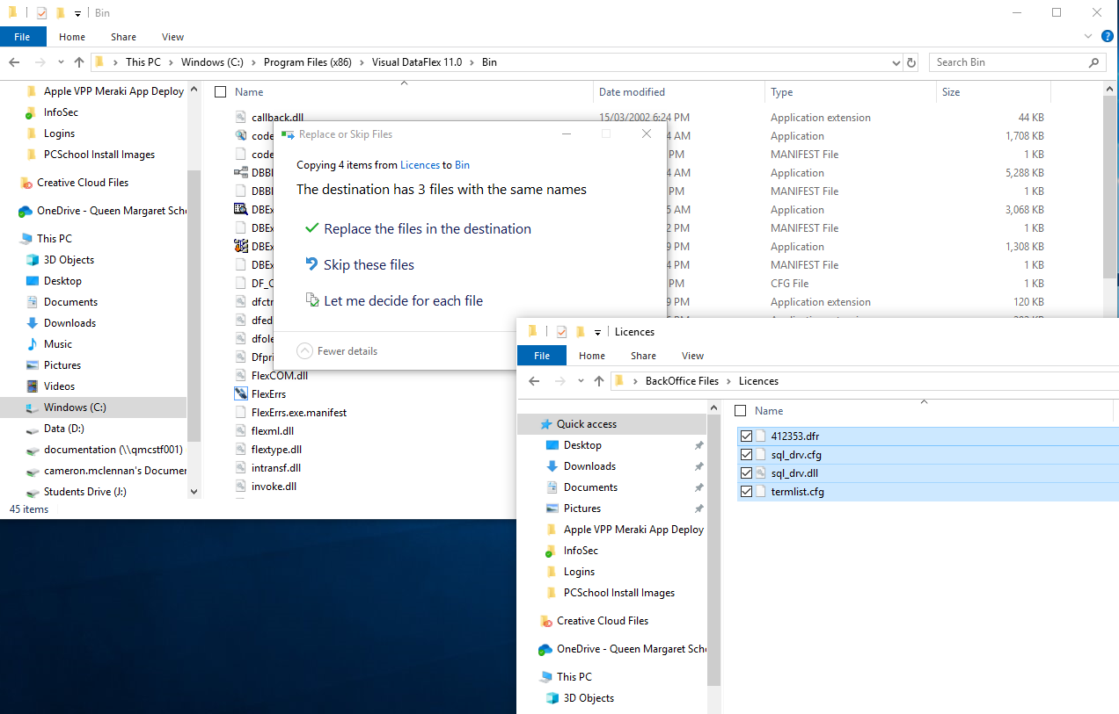 *This PC > c:\ > Program Files (x86) > Visual DataFlex 11.0 > Bin*
* Once you have moved the license files into the Bin folder, run PCSchool as Admin for the first time. You may be prompted to pull updated files from the server, and you should pull the files. Once it has updated, run it as Admin once more just to make sure everything worked. Once you are allowed to log in and have verified everything is installed correctly, you don’t need to run as Admin anymore.